EXPERIMENT 07
Aim: Implement Router as DHCP server that can serve multiple VLAN's.

Learning Objectives
After completing this experiment, we should be able to:
- Understand the concept of VLANs.
- Create and configure multiple VLANs on a switch.
- Assign switch ports to appropriate VLANs.
- Understand the difference between Access Port and Trunk Port.
- Configure a trunk between a switch and a router.
- Understand Inter-VLAN Routing.
- Understand the concept of Router-on-a-Stick.
- Configure router subinterfaces for multiple VLANs.
- Configure a router as a DHCP Server.
- Create separate DHCP pools for different VLANs.
- Automatically assign IP addresses to PCs using DHCP.
- Verify VLAN, trunk, DHCP, and routing configurations.

What is a VLAN?
VLAN stands for: Virtual Local Area Network
A VLAN is a logical network created within a physical switch.
Instead of putting every device connected to a switch into the same logical network, we can divide them into different VLANs.
For example, suppose a college has one switch connected to:
- Student computers
- Faculty computers
- Administrative computers
We can logically divide them as:
VLAN 10 → Students
VLAN 20 → Faculty
VLAN 30 → Administration
Although all devices may be connected to the same physical switch, VLANs logically separate them.

Why Do We Need VLANs?
Without VLANs, devices connected to the same Layer 2 network generally belong to the same broadcast domain.
For example:
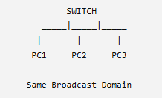
If we configure VLANs:
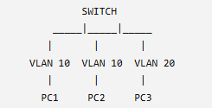
Now:
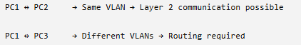
Major reasons for using VLANs:
- Network segmentation
- Security
- Broadcast domain reduction
- Better network management
- Logical grouping of users
What is Inter-VLAN Routing?

Different VLANs are separate Layer 2 networks.

For example:
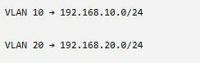
A Layer 2 switch cannot normally route between these VLANs.
Therefore, if:
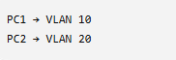
and PC1 wants to communicate with PC2, we need a: Layer 3 device
such as:
- Router
- Layer 3 switch
The process of allowing communication between different VLANs is called: Inter-VLAN Routing

Why Does This Experiment Need Inter-VLAN Routing?
Our router is going to serve multiple VLANs.
Therefore, the router needs to have a Layer 3 interface for each VLAN.
For example:
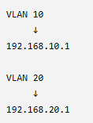
These router addresses will act as the default gateways for the corresponding VLANs.
What is Router-on-a-Stick?
This is one of the most important concepts in this experiment.
Router-on-a-Stick is a method of performing Inter-VLAN Routing using:
One physical router interface divided into multiple logical subinterfaces.

For example:
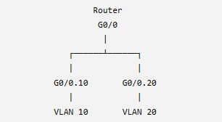
Here: G0/0 is the physical interface.
We create:
G0/0.10
G0/0.20
These are subinterfaces.

What is a Subinterface?
A subinterface is a logical interface created from a physical router interface.
Instead of needing:
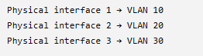
we can use:
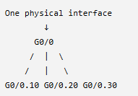
Therefore, one physical interface can handle multiple VLANs.

VLAN Tagging
When multiple VLANs travel over a trunk, the receiving device needs a way to determine:
"Which VLAN does this Ethernet frame belong to?"
This is achieved using VLAN tagging.
The commonly used standard is: IEEE 802.1Q
802.1Q adds VLAN identification information to Ethernet frames when they are carried across a trunk.
Conceptually:
Normal Ethernet Frame
↓
802.1Q VLAN Tag
↓
Tagged Ethernet Frame
The VLAN ID tells the receiving switch/router which VLAN the frame belongs to.

Role of 802.1Q in Router-on-a-Stick
The router needs to know which VLAN a received frame belongs to.
For example:
VLAN 10 frame
↓
Trunk
↓
Router G0/0
↓
G0/0.10
Similarly:
VLAN 20 frame
↓
Trunk
↓
Router G0/0
↓
G0/0.20
The command:
encapsulation dot1Q 10
will tell the router that the particular subinterface is associated with: VLAN 10.

What is a Default Gateway?
A default gateway is the device that a host sends packets to when the destination is outside its local network.
For example:
PC1
IP: 192.168.10.10
Subnet: 255.255.255.0
Gateway: 192.168.10.1
If PC1 wants to communicate with:
192.168.20.10
PC1 realizes that the destination belongs to another network.
So it sends the packet to:
192.168.10.1
which is the router's VLAN 10 interface.

What is DHCP?
DHCP stands for:
Dynamic Host Configuration Protocol
DHCP automatically provides network configuration information to client devices.
A DHCP server can provide:
- IP address
- Subnet mask
- Default gateway
- DNS server
- Lease information
Without DHCP, an administrator may have to manually configure each computer.

Why Do We Need DHCP?
Imagine a network with: 500 computers
Manually configuring:
IP address
Subnet mask
Default gateway
DNS
for every computer would be time-consuming and error-prone.
With DHCP:
PC
↓
DHCP Request
↓
DHCP Server
↓
IP configuration automatically assigned
This makes network administration easier.

Can a Router Act as a DHCP Server?
Yes.
A Cisco router can be configured to act as a:
DHCP Server
In our experiment, we don't need a separate dedicated DHCP server.
The router will perform both:
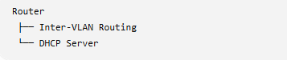

DHCP and Multiple VLANs
This is the core idea of our practical.
Suppose we have:
VLAN 10 → Students
VLAN 20 → Faculty

We want:
VLAN 10 PCs
↓
DHCP
↓
192.168.10.x addresses
and:
VLAN 20 PCs
↓
DHCP
↓
192.168.20.x addresses
Therefore, the router will have separate DHCP pools.
Conceptually:
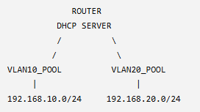

DHCP Pool
A DHCP pool defines the network from which the router will allocate IP addresses.
For example:
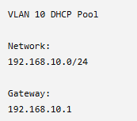
Another:
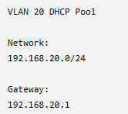
Therefore:
VLAN 10 → VLAN10_POOL
VLAN 20 → VLAN20_POOL

DHCP DORA Process
DHCP generally works using four major steps called:
DORA
D — Discover
Client broadcasts a DHCP Discover message.
"Is there a DHCP server available?"
O — Offer
DHCP server offers an IP address.
"I can give you 192.168.10.10."
R — Request
Client requests the offered address.
"I want 192.168.10.10."
A — Acknowledgment
Server confirms the allocation.
"You can use 192.168.10.10."
So:
D → Discover
O → Offer
R → Request
A → Acknowledgment

DHCP Excluded Address
We generally don't want DHCP to assign certain addresses to clients.
For example, our router's VLAN 10 gateway will be:
192.168.10.1
We don't want DHCP to give:
192.168.10.1 to a PC.
Therefore, we can exclude it from the DHCP allocation range.
Conceptually:
192.168.10.1 → Router
192.168.10.2 → PC
192.168.10.3 → PC
192.168.10.4 → PC
...

Complete Conceptual Architecture
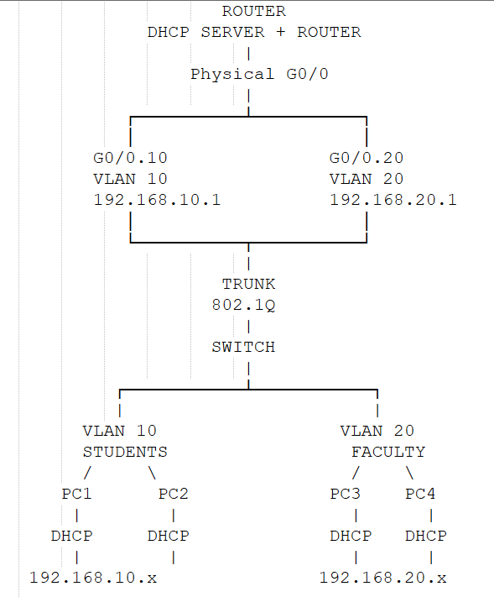

What Exactly Will Happen?
Let's follow one PC.
Suppose PC1 belongs to VLAN 10.
Initially PC1 doesn't have an IP address.
Step 1
PC1 sends a DHCP Discover.
PC1
↓
DHCP Discover
Step 2
The switch knows PC1 belongs to:
VLAN 10
Step 3
The VLAN 10 traffic reaches the router through the trunk.
PC1
↓
VLAN 10
↓
Switch
↓
Trunk
↓
Router
Step 4
The router's VLAN 10 subinterface handles the request.
G0/0.10
192.168.10.1
Step 5
The router's DHCP pool for VLAN 10 provides an address.
For example:
192.168.10.2
Step 6
PC1 receives:
IP Address: 192.168.10.2
Subnet Mask: 255.255.255.0
Default Gateway: 192.168.10.1

What Happens with PC3?
PC3 belongs to VLAN 20.
Its DHCP request follows the VLAN 20 path:
PC3
↓
VLAN 20
↓
Switch
↓
Trunk
↓
Router
↓
G0/0.20
↓
DHCP Pool VLAN 20
The router may assign:
IP Address:
192.168.20.2

Subnet Mask:
255.255.255.0

Default Gateway:
192.168.20.1
So the router automatically understands:
VLAN 10 → Give 192.168.10.x

VLAN 20 → Give 192.168.20.x

Experiment Demonstration:
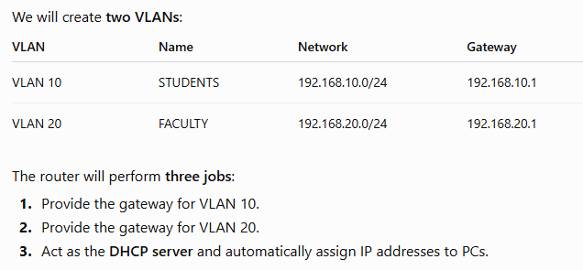

Step 1 — Open Cisco Packet Tracer
Open Cisco Packet Tracer.
We will create the topology manually.

Step 2 — Add the Devices
We need:
1 Router
Choose:
Network Devices → Routers → 2911
Place one router.
Rename it: R1
2 Switch
Choose:
Network Devices → Switches → 2960
Place one switch.
Rename it: S1

3 Four PCs
Choose:
End Devices → PC
Place four PCs.
Rename them:
PC1
PC2
PC3
PC4
So your topology contains:
1 Router
1 Switch
4 PCs

Step 3 — Connect the Devices
Now we physically connect them.
We will use Copper Straight-Through cables.
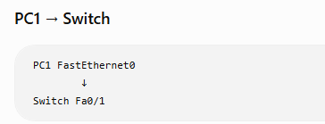
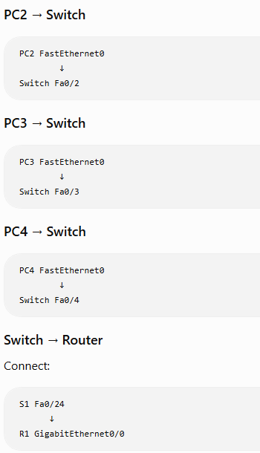

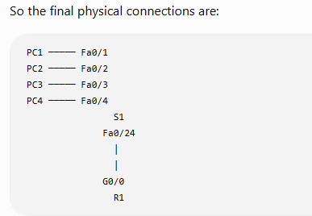
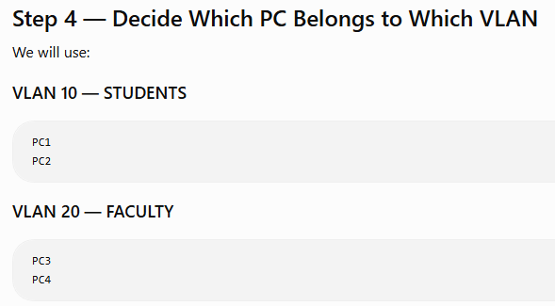
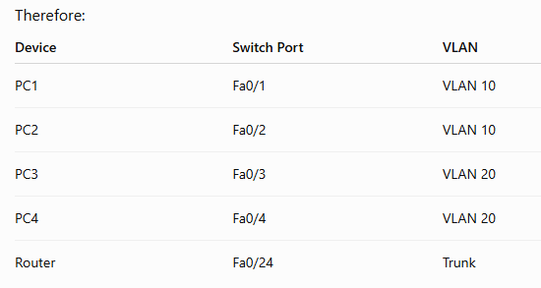

Step 5 — Configure the Switch
Now we start actual Cisco IOS configuration.
Click S1.
Go to:
CLI
You will see something similar to: Switch>
The > symbol means we are currently in: User EXEC Mode

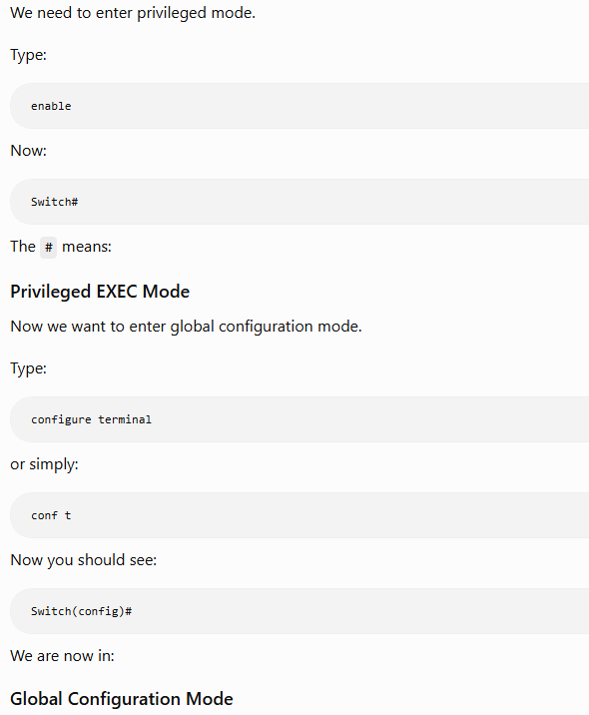

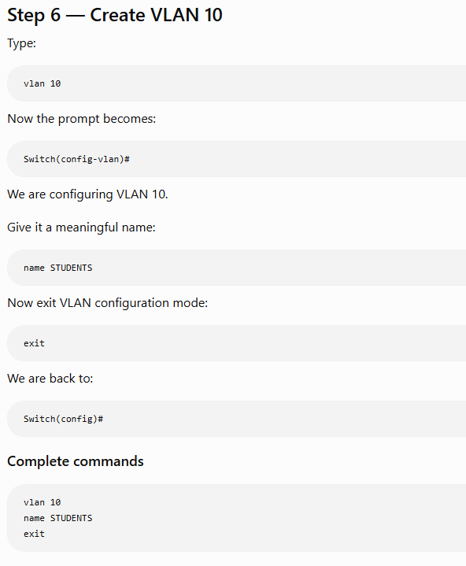

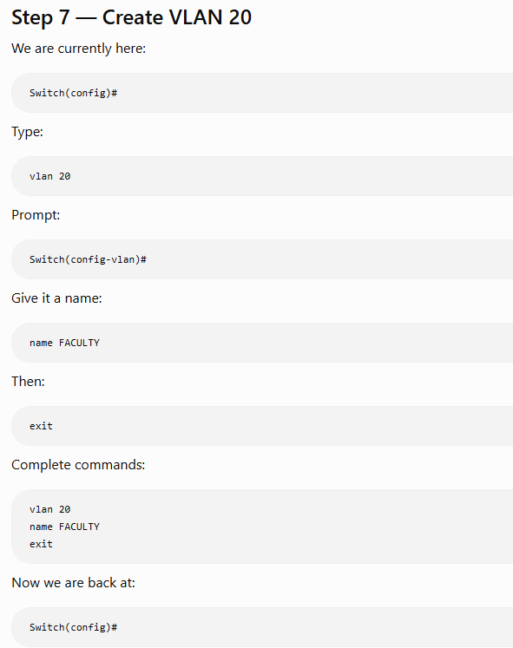

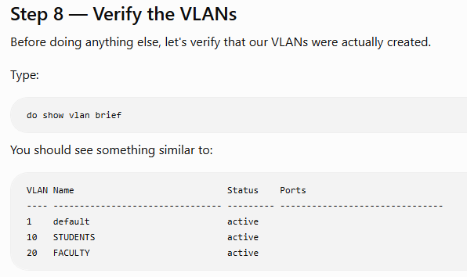
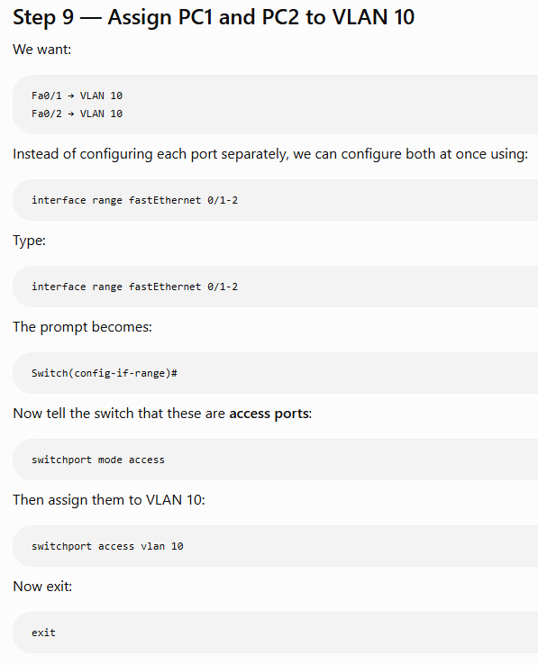

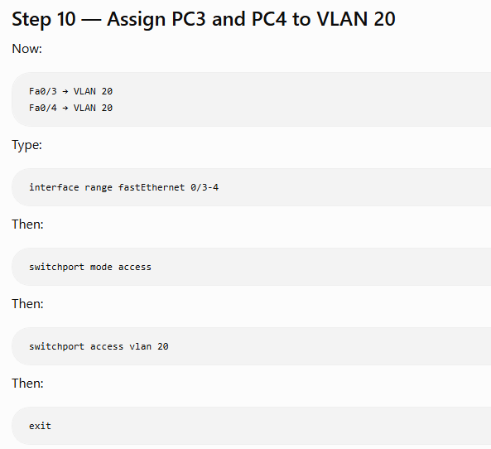
Step 11 — Verify VLAN Assignment
Now run: show vlan brief

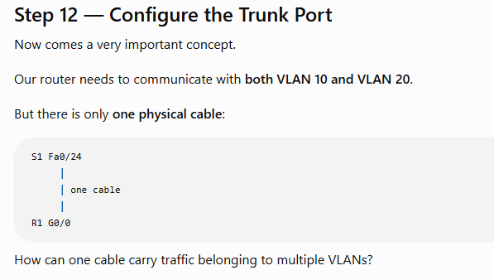

Answer: TRUNK
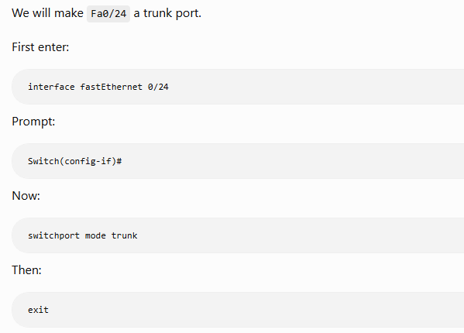

Step 14 — Verify the Trunk
Now the prompt should be:
Switch#
Run:
show interfaces trunk
You should see Fa0/24 listed as a trunk.
This verifies that our switch is ready to send multiple VLANs toward the router.

Part 2 — Configure Router R1
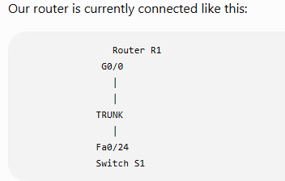
Now we need to tell the router:
“When you receive VLAN 10 traffic, use one logical interface and gateway. When you receive VLAN 20 traffic, use another.”
This is done using subinterfaces.

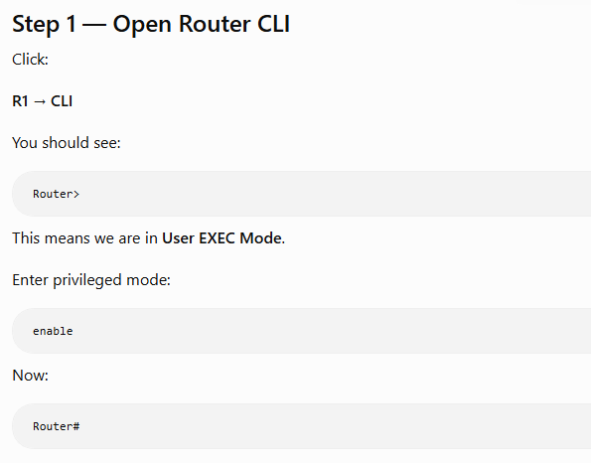

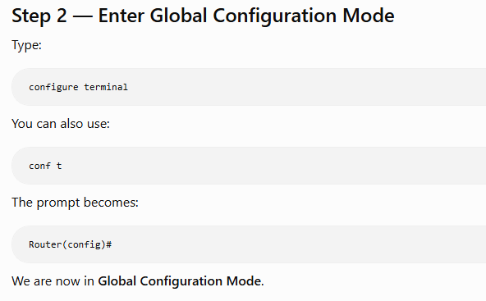

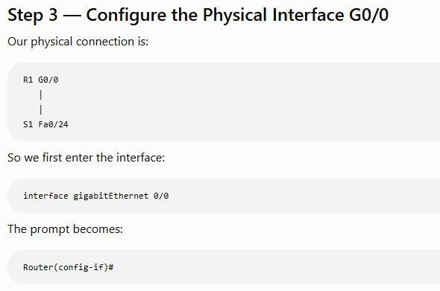
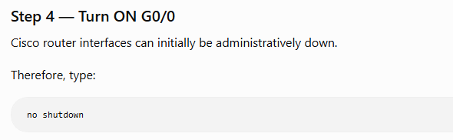
You may see messages such as:
%LINK-5-CHANGED: Interface GigabitEthernet0/0, changed state to up
%LINEPROTO-5-UPDOWN: Line protocol on Interface GigabitEthernet0/0, changed state to up

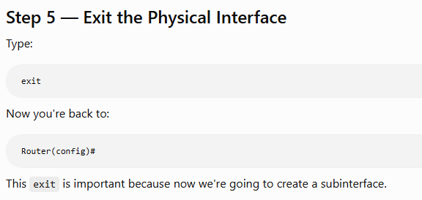
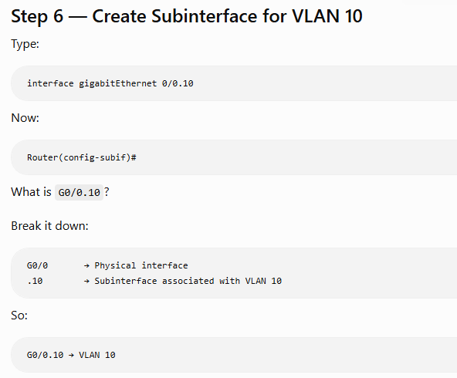

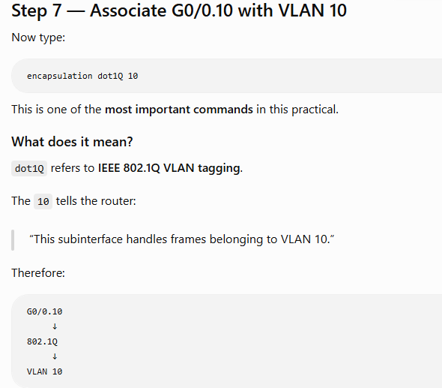
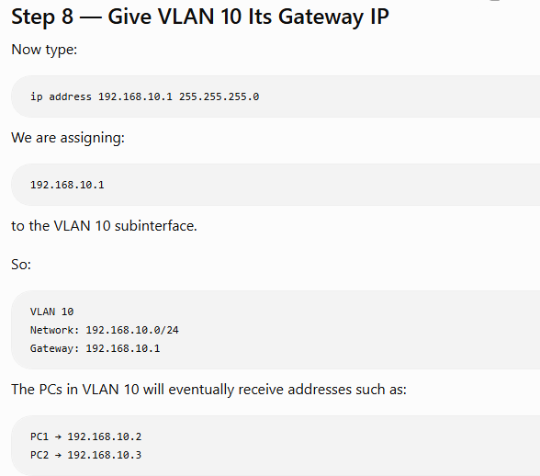
and their default gateway will be: 192.168.10.1

Now Exit the Vlan 10 Subinterface
Type: Exit
Now:
Router(config)#

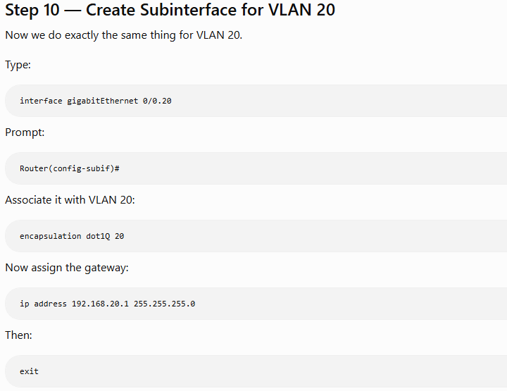

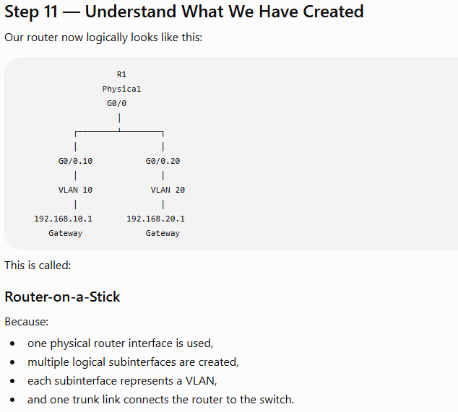

Step 12 — Verify the Router Interfaces

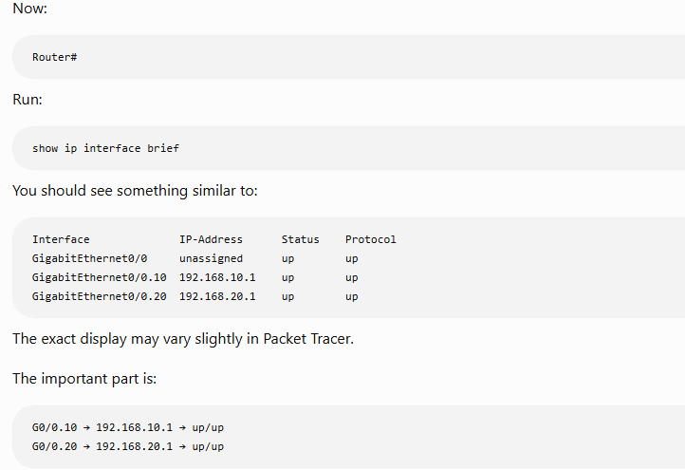

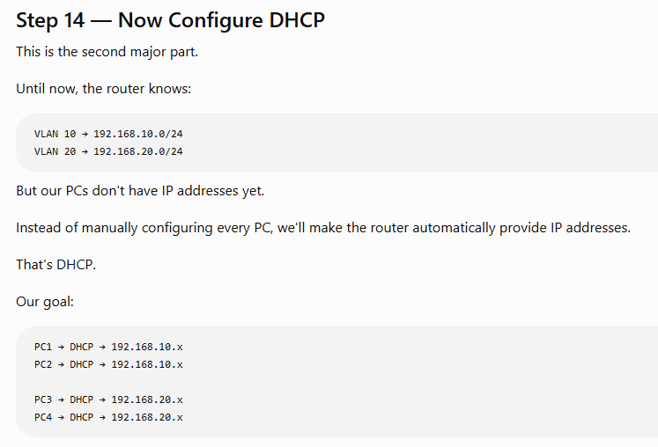

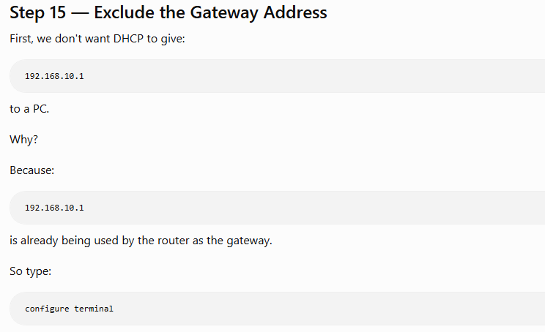
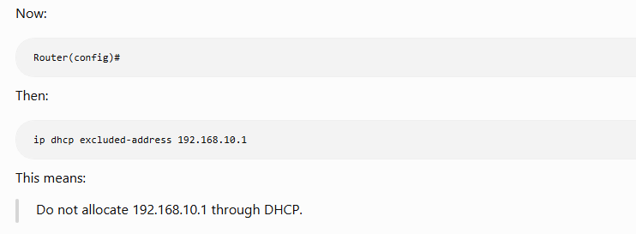

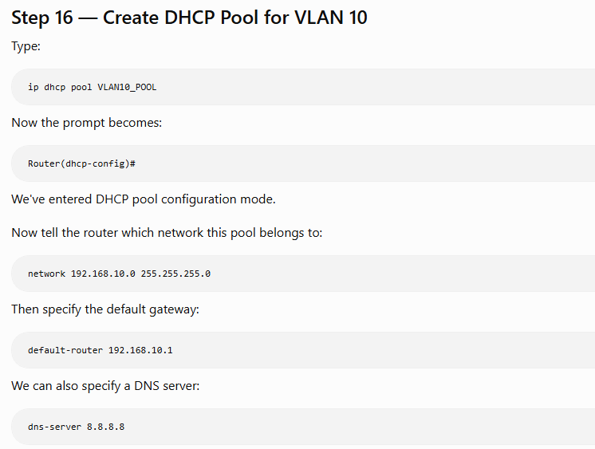
Then exit.

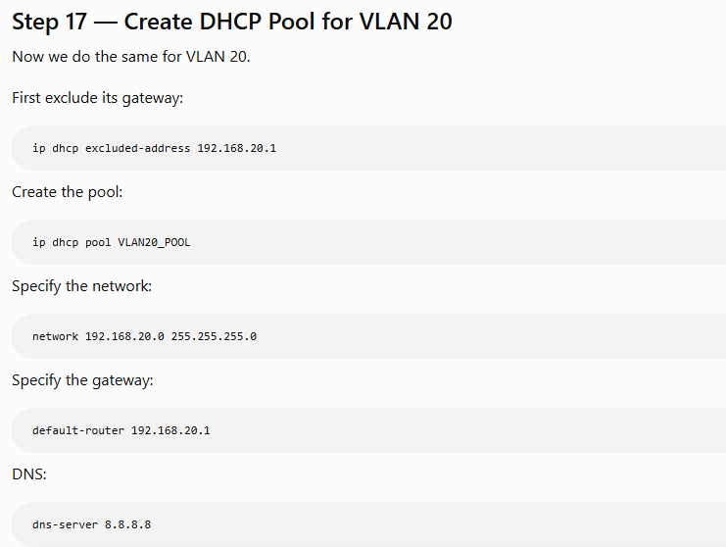
Then exit.

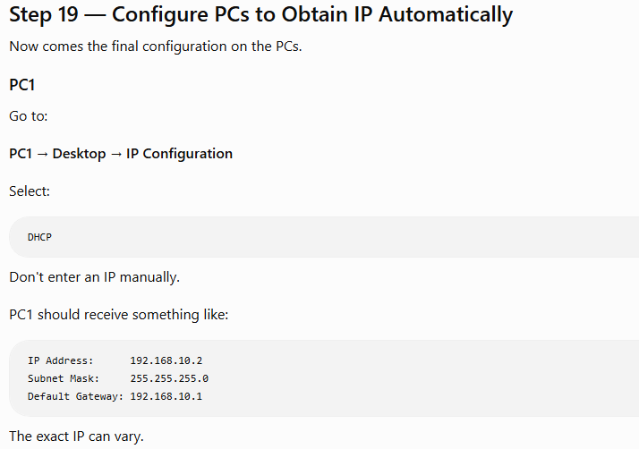
Same for PC2, PC3 and PC4.

